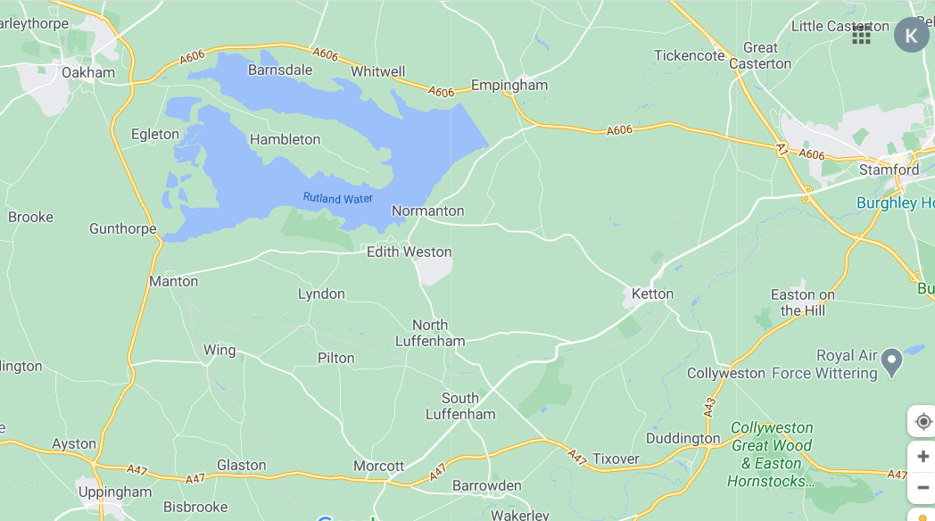
Manton Bridge to be demolished and rebuilt = road closure and diversion route put in place 12/04/21 – 05/07/21
Normal RF1 route between Oakham and Uppingham with inclusion of Wing 3 times per day
Manton Bridge being demolished and rebuilt – road closed
official diversion route – does not cover Manton, Preston, Wing or Gunthorpe
alternative route for RF1 – Gunthorpe not served

