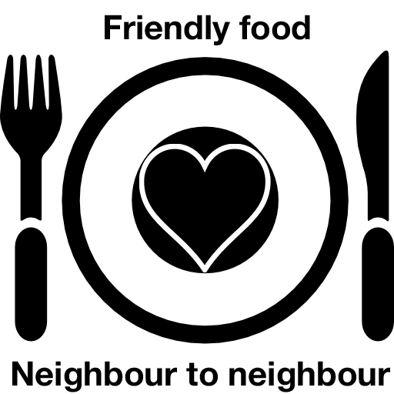
Meal contributor
registration form

Please complete all boxes and return to Rachel at 1a Church Street, Cottingham, or email racheldhudson@hotmail.co.uk, or by sms to
07956 363869.
Your name
Best number to contact you on
Email address
Which is/are the best day(s) of the week for you to provide a meal to somebody in the villages?
Are there any times when you will not be available (holidays booked, for example)? This can be updated at any time.

Your personal data

The personal data you provide (your name, address and contact details) will be used solely for the furtherance of the Friendly Food project. It may be shared with the person (or people) for whom you are preparing meals but will not be shared with any third party. Your data will be kept up to date, securely stored and destroyed (when necessary) and protected from unauthorised access, unauthorised disclosure, loss, misuse, alteration or corruption. Please tick here to confirm you understand and agree to this.

Thank you, we will be touch when the project starts, whereupon we will give you a full briefing prior to your involvement commencing.

Thanks very much.

Kirsty and Rachel.

